Media relations

Training materials | Version 2  5 2019

Table of Contents
Introduction 3
A. Basic information 4
1. Formatting content 4
2. Press Release 8
3. Interview 13
4. Photography 14
5. Creating a database and distributing content 16
B. Further information 18
6. Building relationships 18
7. Media monitoring 19
8. Crisis management 22
9. Bibliography 25

Introduction
Media relations – i.e. establishing and maintaining positive relations with the media - is a subset of public relations activities. Effective media relations activities allow for the obtaining of additional coverage through publications in the press, on radio, television and the Internet. To achieve this, it is necessary to be able to create materials of the right quality and understand the needs of journalists, only in this way is it possible to convince them that we are providing valuable content that will be interesting for media recipients, not just intrusive promotion.
In these training materials, we will learn how to create content, so that it is readily published by journalists, what to pay attention to during interviews, how to create good relations with editorial offices, and we will also learn the rules of organizing press conferences and managing communication in a crisis.

- Basic information
- Formatting content
We have a theme, interesting information, and a big event that should be promoted in the media. How should we go about it? There are many ways - content on social media, posters, word-of-mouth marketing and media relations. In this document, we will look at this last area.
One of the basic tools in media relations is the press release, that is news that journalists will receive and want to publish. For this to happen, the topic must be not only interesting and newsworthy, but it should also be properly presented. This task is not as simple as it appears at first glance, and the key to understanding it is the way people currently receive content, especially that published on the Internet. Let's consider how it looks in specific examples.
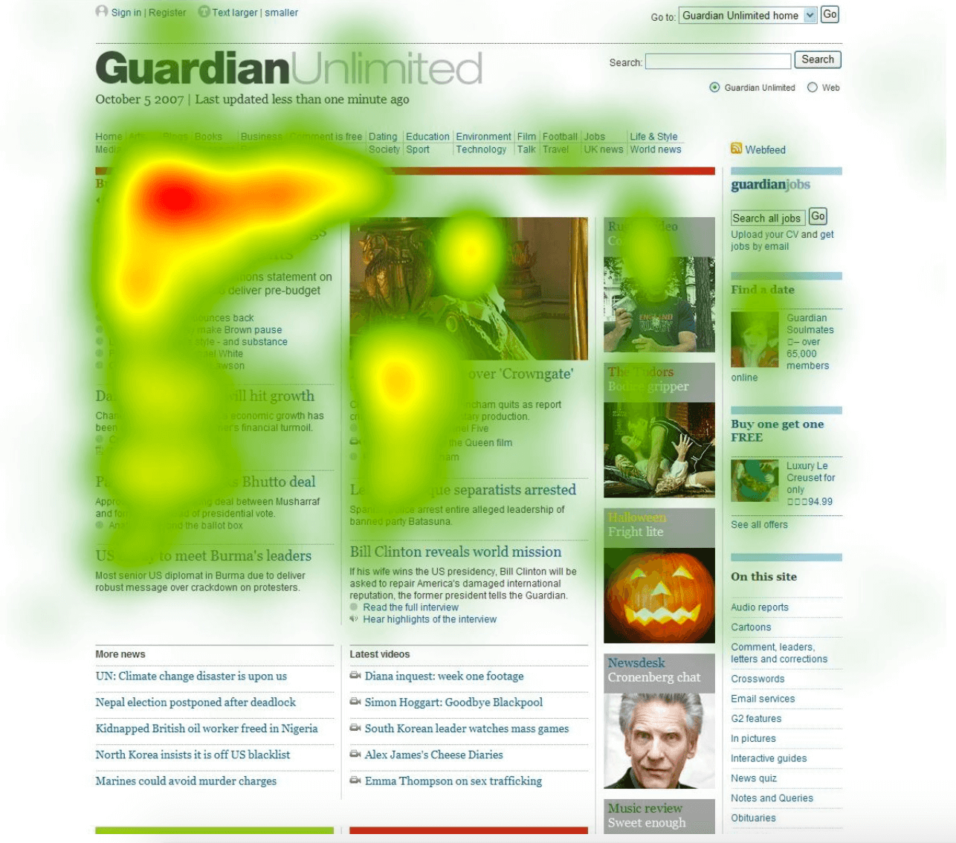
Figure 1. Heat map of a webpage
Source: https://www.crazyegg.com/blog/understanding-using-heatmaps-studies/
So-called heat maps help in understanding how recipients on a website move around it. They are created using various tools, such as "eye tracking". This technology tracks the movement of the eyeballs and on this basis determines on which elements of the displayed image the user has focussed for a longer time. The longer he looked at on a section, the more intense the colour.
From the presented heat map for the GuardianUnlimited website, it appears that its users pay attention to the upper left corner of the page and to the pictures. However, this is not a universal truth about all users and all sites - everything depends on the layout of the content on a given website. Most attention is always drawn to the title and lead (that is, the bold fragment located just below the title, most often containing condensed information about the content of the text), and in further parts of the text the user almost consistently loses interest. The "drop in interest" is not completely unambiguous - as we can see, in a few places the map shows an irregular increase in interest in the content coinciding with the next underlined titles. It is also worth noting that the content on the right goes almost unnoticed for GuardianUnlimited users. On this basis, two conclusions can be drawn regarding the effective formatting of information that is intended to reach the Internet:
- Use different features that will draw attention.
- The most important content should be on the left (as high as possible).
A common belief about media reception is that users read content from the beginning to the end, while all the time being as focused as possible. This is quite obviously untrue, but it is easy to forget that when preparing your own press release. That is why it is worth finally verifying this belief and forming the habit of proper formatting of texts.
Figure 2. The actual way Internet users read content
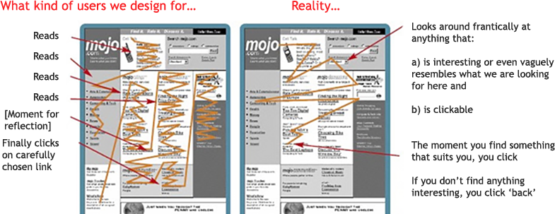
Source: https://medium.com/nyc-design/eye-tracking-and-the-best-ux-practices-in-the-mobile-world-a101f67f20dd
So when talking about contemporary Internet users’ reception of content, a more adequate word than "reading" would be "scanning" or "browsing". There are several reasons for this, and they result from various causes. The culture of reading printed text differs from that of text displayed on a screen, and the Internet itself is perceived as a typically functional medium, which allows us to quickly find the content that interests us. All of this translates into causes that result in Internet users tending to generally scan content on web pages instead of carefully getting to know it, as illustrated in Figure 3.
Figure 3. Reasons for users not reading all of the content displayed on a site
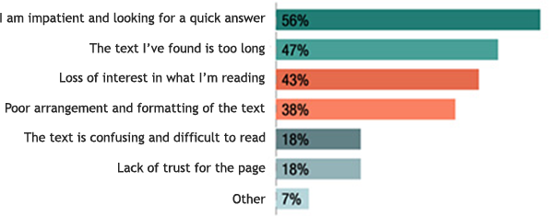
Source: https://dejanseo.com.au/web-content/
As the chart shows, the biggest problem is lack of patience in searching for answers that are interesting to the user. Proper formatting, therefore, is not ‘art for art’s sake’ or just a question of aesthetics. First of all, it makes it easier for the recipients to search for the information that they find most interesting. For this to be the case, the text should be clearly divided and have characteristic solutions that will draw the attention of the recipient to a specific element. For this to be the case, various types of text markers should be used:
- Bullets - a transparent way to list items. It is a much more attractive form than placing consecutive elements in one sequence after a colon. Bulleting puts the content in order, makes it easier to search for the information that is most interesting for us, facilitates scanning of the text and makes it more diverse.
- Figures and numbers - numerical figures always catch the eye, so it is not worth writing them in words. Larger numbers can be written using words, e.g. 20,000 or 3 million.
- Links - it is impossible to imagine the Internet without hyperlinks, so you should use them in texts. Not only do they draw attention, but they also give us the opportunity to redirect users to our external websites. The link should be formatted in the form of a so-called anchor link (instead of the full address in the form of https://www.google.com/, you can simply present it as linked Google text).
- Bold - the most basic way to highlight a part of the text. It is best to put in bold important information that due to necessity finds itself in places that are less favourable from the perspective of reception (e.g. in the middle of a paragraph), and so it could become lost in the jungle of other sentences.
- Headers - an article itself being divided into smaller parts increases clarity and gives the recipient the opportunity to find out what the next concrete fragments will be about. This is a great way to encourage the user to read the whole paragraph - you only need to encourage the reader accordingly!
- Pictures and graphics – these enrich the text and draw attention. A good infographic helps to easily solve complicated issues that would require many long paragraphs.
- Tables and graphs - data are best visualized using tables and graphs, because they are the most transparent. They attract the eye for a longer time - recipients like statistics and numbers, so a decent combination will keep them for a little longer.
- Italics - opinions are divided here. There are supporters of italics, who claim that they are ideal for highlighting statements and quotes, as has been accepted. On the other hand, italics are harder to read than unformatted text.
Conscious and reasonable application of the text distinguishing marks will allow it to be divided into smaller fragments that are easy for the recipient to scan through, and for highlighting the most important parts, drawing attention and improving the aesthetics of the entire material. Thanks to this, we have a better chance of encouraging the reader to become acquainted with our article or - if he finds that he does not have time - to communicate to him the key issues raised in the publication.
Speaking of distinguishing features, it is also worth talking about exceptions that should not be used. When creating materials, it is recommended to avoid writing whole words in CAPITAL LETTERS. For two reasons:
- Capital letters are harder to read.
- It is assumed that they signify shouting (especially on the Internet).
It is worth saying a few words about links. There are several ways to describe links embedded in the text. The most common formulas are: "Link", "More", "Click here" or simply "Here". Such naming has one big disadvantage - the reader is not sure where he will be taken to after clicking the link. Therefore, a much better solution is to describe the link in a specific way, which tells the internet user which page will be displayed to them after clicking the hyperlink. The user needs to know where the link will take him. Link descriptions should also be as short as possible - it is a mistake to mark entire paragraphs or sentences.
The basic principle of placing links embedded in the text says that they should be at the end of a sentence or paragraph. This is the best solution due to the fact that thanks to this the reader will read the sentence or a given text fragment to the end. It is very important that the address embedded in the link is correct and will lead to an existing page. A broken link is a very large disincentive to reading.
Using unified formatting rules for a text significantly increases its aesthetics and transparency. Systematic principles used when writing an article allow the reader to pay attention to the most important information contained in the text.
Correct formatting is especially useful in texts that contain a large amount of detailed information. This allows the highlighting of key issues and significantly shortens the search time for specific messages.
The basic principle of formatting is to deal with it after writing the entire text. This allows the assessment and selection of words, content and messages that the reader should pay special attention to.
When formatting a text in the correct way, it is also worth observing the following rules:
- do not insert spaces before a punctuation mark (e.g. before a full-stop, comma, exclamation mark),
- do not insert spaces after an opening bracket or before a closing bracket,
- use a uniform font - too many different typefaces in the text may distract the reader's attention.
The use of correct formatting is one of the key issues at the first stage of material collection. It should encourage aesthetics, because sometimes the first impression determines whether it will be read. The application of the above rules will significantly increase our chances of effectively reaching more readers.

- Press Release
Having got to know the most important rules regarding the formatting of content, it is worth moving on to the particular journalistic genres that we will use most often. The main such type is the press release.
The principles for creating properly constructed newspaper articles are presented in the so-called inverted pyramid. This indicates that the most important information should be at the very top of the article, and increasingly less important content should be placed in more and more distant parts of the text.
Figure 4. The inverted pyramid of the press release
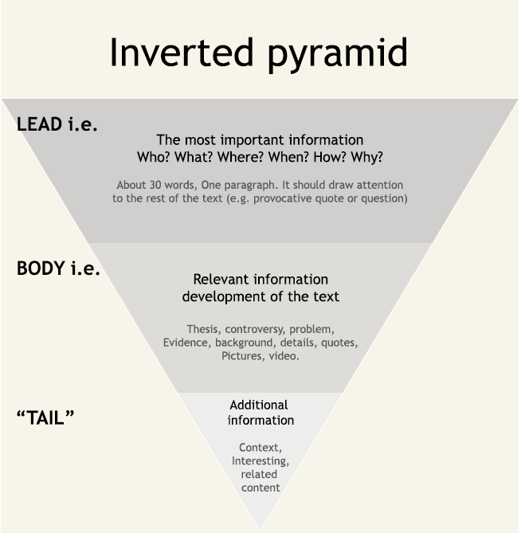
Source: https://www.slideshare.net/mindsupporterscom/odwrcona-piramida-70097847
The principle of the inverted pyramid has been used by professional journalists for years, but still today it has not lost its relevance. However, this is for different reasons - it used to be space in the newspaper. A journalist writing a text did not always know how long his material could be, because the publisher, together with the person who was putting the whole newspaper together, could have considered that the texts from other editorial staff were more interesting. To facilitate the cooperation of journalist and publisher, the principle of an inverted pyramid was created. Thanks to its use by the journalist, the publisher knew that he could shorten the text from the last paragraphs, because the key information had already been included. Today, there is no such problem in the area of the Internet. However, the inverted pyramid has one more advantage which has retained its functionality to this day: it presents in the easiest way possible the issues in the message that the recipient regards as key.
Figure 5. Questions that should be answered in the lead
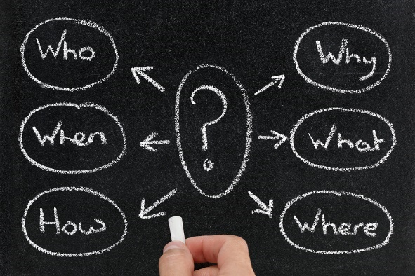
Source: http://foodasartisticmedium.altervista.org/about-f-a-m/
- What happened?
- When did it happen?
- Where did it happen?
- Why did it happen?
- Who is the hero of the story?
- How do we know this?
Before the question "How?" was added, the principle of creating a lead was called the 5W principle - from the first letters of 5 questions. The answer to all 6 questions gives the recipient a package of the most important information referred to in a given news story (news - topical, current information). In practice, media relations activities often ignore the last question, because the answer to this stems from the very source of dissemination of information.

Figure 6. Characteristics of a good press release

Source: elaboration based on http://www.proto.pl/porady-praktyczne/amet-augue-lobortis-vulpes
On what occasions might a press release be useful in the area of intangible culture? It is certainly a good solution for the organization of cultural events - performances, concerts, shows. It is also worth using in the case of various types of premieres. Culture is a topic that the audience likes very much, so press releases will also work in the event of unusual events, happenings or performances.

Exercise (20 min)
- Prepare a press release about what you are doing.
- Think of a catchy title.
- Write a lead that answers the most important questions.
- Sketch the structure of the following paragraphs by proposing 2 subheadings. Written

Before the press release reaches the recipients, it must be verified by a journalist who decides whether it should be published. To increase the chances of that for your material, you should try to make it interesting, well-formatted and prepared, taking into account the principles of journalistic techniques. The most important of its principles are:
- Focus on thinking in terms of the recipient of a given medium and answer the question of which articles will be interesting to him. Simply presenting a problem is not enough. Therefore, remember that the material developed should provide the reader with not only information, but also knowledge about a solution to the problem being addressed. And the most important: both journalists and recipients are looking for news in the article. Create unique texts and provide only current information.
- Thesis, i.e. I know what I want to convey - before you create the text you need to know what you want to write. The reader does not need to know the thesis, but for you it will be a signpost and map, thanks to which the article will always be on the topic and will not "dissolve" into side plots. A concept of the material will allow you to develop a text in line with the adopted assumptions.
- Journalistic research - if you already have an interesting topic and know what you would like to write an article about, the next step is to get the information you need. The messages themselves are not enough. Put yourself in the place of a journalist, find experts who will speak about the material.
- Accurate title, for a good start - journalists receive dozens of e-mails every day, from which - after a cursory analysis - they choose those that are suitable for reading. Due to lack of time they usually only read the title. It must encourage the journalist to read the whole text. Sometimes a good joke, a paraphrase or a quote will work out well. Avoid using exclamation marks. Do not write the whole title in capital letters.
- The lead is "Your 5 lines" - if the journalist decides to open your message, immediately after the title he will read the lead. The principle is simple: the information contained in it is either interesting or not. Here is your "to be or not to be" moment. Describe the quintessence of the problem, surprise with data contrary to popular opinion, suggest an original solution.
- Divide the text - none of us likes to read long, boring and pointless texts. Information sent to the media must be logical, so try to group your material into paragraphs. Divide them with creative, punctuating sub-titles. This will increase the likelihood that the reader will read the text to the end.
- The 5w principle and the inverted pyramid - reading the first few lines of the text should enable the reader to find answers to the questions: What happened? Who took part in it? Why did this happen? When? Where? What is the conclusion? Thanks to this, the recipient will know the most important facts after reading the lead itself. It is important that the information becomes more and more detailed as the text goes on.
- Less is more - a press release should not be more than 2 pages long, and the size of the whole message cannot exceed 1MB. Some editorial offices have boxes blocked for messages exceeding this "size". This is proved by return messages received.
- Hire a proof-reader - do not be under any illusion, for even a second, that your text does not need to be corrected. Ask a few people to read it and encourage them to boldly criticise. Sometimes readers have a completely different impression, not necessarily consistent with the author's intention. Confront it and eliminate errors that you may not see yourself.
The preparation of an attractive press release that is published by a journalist, is a real success. We do not have to pay for advertising in the media (which always costs a lot), and at the same time we gain publicity through channels that are not available to us on a daily basis. This is one of the basic ways to reach a wide audience, which is why it is so important to make good use of the opportunity that press releases give us.

- Interview
A press release is not the only type of material that the media may be interested in. An interview is a good solution to create an image of an individual artist.
"It should be borne in mind that direct contact is the best way to contact the media. In this case, anonymity (lack of knowledge about the person's details) is completely eliminated. Direct contact puts the relationship between the journalist and the interviewer in a different light, because the information is related to a specific person.
From the point of view of preparing or authorising an interview, the frequency that the publication is issued as well as the date and time of closing the number are also important. Each editorial office has specific rules and deadlines. It is different in a journal, weekly, monthly or quarterly. The electronic media, Internet, radio and television, are governed by completely different laws.
It is also very important whether the interview is broadcast live or recorded. In the first case you must not allow yourself to be late, let alone forget about the interview. Its time is fixed, and this should be observed" .
A few tips on interviews:
- Be prepared in the substance.
- Express yourself clearly, concisely and sequentially.
- Relate your answers to the questions asked, do not go into too extensive digressions.
- Know your rights - in some countries the tradition of authorization is still alive.
Do not be afraid to talk to the media! The interview is one of the journalistic genres that are more accessible to the recipient. It should also be remembered that it will not only allow you to promote your work, but also give you a chance to build your image as an artist who is worth following.

- Photography
Having a ready interview or information, we need to complete it with visual elements, i.e. most often pictures. Good photography not only catches the eye, but is also part of the creation of a positive image.

Figure 7. What is worth remembering when choosing a press photo

Source: elaboration based on Adam Łaszyn, Media and you, 2015
Remember that in the internet era a good picture can have an independent existence. It happens, after all, that images of individuals are known all over the world, and only a small group of people know the actual name and surname of the figure immortalized in the picture. That is why it is worth taking care to achieve the highest quality of photography, because it will allow us not only to get a journalist to publish material, and make up an aesthetic complement, but it may become a main element that will provide us with wide promotion.

Exercise (10 min.)
- Look at the three photographs. Which photo would you choose if you were to send out a press release regarding the next big event organized by Apple? Justify the answer.
Figure 8. Photograph 1
Source: https://venturebeat.com/2018/09/13/10-key-things-you-missed-at-apples-september-2018-gather-round-event/
Figure 9. Photograph 2
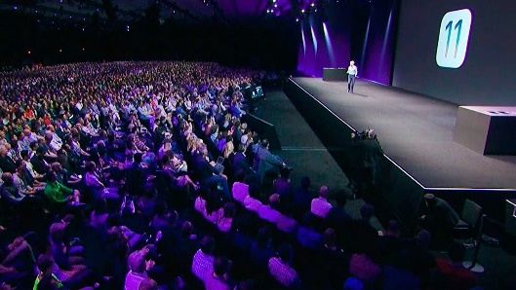
Source: https://www.youtube.com/watch?v=i5ACY3OiDQ04
Figure 10. Photograph 3
Source: http://www.itcertswin.com/what-you-should-expect-about-apple-march-event.html
- Creating a database and distributing content
When we already have materials prepared, then we should define the target group and create media base based on it.
The media is divided into:
- Local - relatively small editorial offices and small reach, but often with more impact on the local community.
- Nationwide - huge reaches, a lot of material published each day.
- Sectoral - media precisely targeted to particular professional groups, hobbyists, etc.
As a creator of intangible culture, you should first of all think about whether there exists industry media that address topics related to your business. A thorough review of the media may surprise you and create the possibility of cooperation with a niche magazine, whose editorial staff will be positively asking you to send materials.
The situation is slightly different with local and national media. They have a general-interest profile and a dedicated section dedicated to culture (supplement). This is where you should go. Make an effort to establish direct contact with the thematic journalist, maybe you share common cultural interests. Let him get know you - the chance of publication is greater if the journalist knows the person sending the material than if the sender is completely anonymous to him.
Our database of journalists, which should be prepared in an Excel sheet, should consist of the following basic elements:
- Name and surname.
- E-mail address.
- Phone number.
- Editorial office.
When creating a database of journalists to whom we intend to send materials, we can only use publicly available data. If we have received a database from a friend and there are addresses in it that cannot normally be found on the Internet, we should not use them due to the GDPR (General Data Protection Regulation).
When sending materials, you should remember to paste the e-mail list into the "Blind carbon copy" field. Thanks to this, each of the journalists will receive the e-mail, but they will not know who else it has been sent to - which solves a possible problem with the GDPR.
Regarding the time of dispatch, although the best time is different for particular editorial offices, it is recommended to send materials in the morning (7: 30-9: 30), from Monday to Thursday (the sooner the better). Morning hours are a good time for a journalist to familiarise themselves with our content before an editorial meeting, whereas when it comes to days - on Friday, the majority of editorial offices already have carefully planned publications for the whole weekend, so nothing new will be added to the already created plan. However, if we have information about the nature of a particular editorial office, it is worth taking this into account when planning the dispatch.

"Take an interest in the industry
In every editorial office (television, radio, press or internet) there are sections dealing with a specific topic. Among others, this is due to the fact that one journalist may be better at reporting events, while another, thanks to his inquisitiveness, creates engaging intervention materials, and a third conducts interviews with ease. Each of them is a specialist in their field. If you serve a client from the financial industry, you should know what is currently happening in the economy and how you invest in the stock market. Browse the press, read the portals and carefully observe the changes - thanks to this you will be able to easily offer an interesting and, above all, current topic.
Aim accurately
Is the information you are going to convey a sensation in the industry or a description of an interesting initiative? Do you want to be on the front page of an opinion-leading weekly, or would a publication in the local press be more appropriate? Consider who the information is addressed to and what medium will enable you to reach a specific group of recipients. Carefully choose media and journalists. Schedule the right dispatch time, because each editorial office can have an editorial board meeting at different times".
Creating attractive content for journalists and recipients is a form of promotion for which we do not have to pay. The absence of cost is an undeniable advantage, but it does bring with it the necessity to make the effort necessary to prepare an article that will be published in the media. Thanks to paying for advertising we have a guarantee that our material will appear on the pages of the chosen medium, while in this case we must ensure publication through the quality of the content we provide. It is not an easy task, but it is feasible.
First of all, let's take care of basic issues - appropriate and compliant text formatting. Let us remember that the way texts are read on the internet is different than in the traditional press - on the Internet, readers tend to scan the text, and they will less often get to know it in depth. Also do not forget that the decision to publish is made by a journalist, so we should create our articles based on the principles of journalism.
Do not forget about other ways of reaching recipients - an interesting interview or attractive photo can sometimes reach a lot of people. This is a less obvious way of communication that makes it easier to stand out.
Finally, it is worth remembering about the appropriate distribution of content. For all promotional activities, target groups are referred to and it is no different in this case. It makes no sense to send information about a small event to an editorial office that is located at the other end of the country. On the other hand, sending our press article to a journalist who deals with culture in the place where we operate will give the best results.
Following the rules presented in these training materials will increase the chances of publishing our materials in the media.
- Further information
- Building relationships
Media Relations cannot, however, be reduced solely to the creation and distribution of editorial materials. This attitude is characterized by one-sidedness - we send, and the journalist should publish. However, as the name suggests, Media Relations is about establishing relationships, and therefore also respecting the work and needs of a journalist.
In order to encourage a journalist to be interested in a subject, he should be sent materials taking into account the format that is most attractive for the journalist.
Figure 11. Formats preferred by journalists
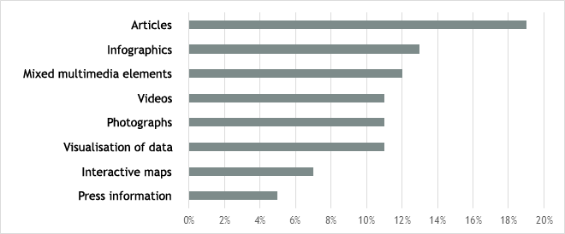
Source: developed on the basis of http://www.mediarelationsblog.com/500-writers-editors-reveal-pitch/
Creators of culture can offer a lot to editorial offices. This can include tickets for a concert, an invitation to another cultural event or a disc to review. A journalist is also a person doing his job, so he wants to be appreciated. If we see a journalist during an event, it is worth approaching them, thanking them for their presence and talking to them.
Show respect to journalists and do not send information to them if it is not needed. This applies especially to the appropriate targeting of the message. If you have created a text about an upcoming festival, do not send it to a science journalist dealing with quantum physics! Editorial boxes are already overloaded with various types of messages.
Media patronage - a great idea for cooperation. The media will gladly take an interesting patronage initiative, and within its framework you can negotiate many activities that will be settled under a barter agreement. Thanks to this, the cooperation will be beneficial for both parties and it will strengthen relations between you and the editorial office.
"The journalist is your partner
Finally, the most important thing: treat the journalist as a partner. Before you create and send a text, and begin impatiently waiting for the results, contact the journalist. Find out what you can help with and what will be beneficial for him. Ask what his expectations and preferences are. What information does he need? In this way, you build relationships with journalists who will find over time that you treat them seriously and responsibly. This is priceless!".
Building bilateral relations with journalists is the best way to ensure your presence in the pages of the chosen medium. A familiar journalist may not always decide to publish our message, but he will certainly look at it favourably or send suggestions that will help us improve our material. However, the creation of such a good relationship must be based on mutual respect and understanding as well as appreciation of the journalist's work.

- Media monitoring
We have sent our materials to the journalists, so what next? Does this already settle the issue of distribution of information? No - the final step will be media monitoring. Only after that - and taking any actions that turned out necessary after monitoring - will you be able to talk about having gone through the entire process of sending content.
What is media monitoring? It involves precise searching for information on the radio, press, television or the Internet. Properly conducted monitoring allows you to regularly broaden your knowledge about an image created in the media and on social networks. Thanks to the use of monitoring tools, you can read the opinions of recipients on an ongoing basis. Monitoring is an invaluable tool in the event of crises, because it allows a real-time response and observation of the pace and scale of the spread of crisis information or content aimed at averting the crisis.
Examples of tools used in media monitoring:
- Google Trends - thanks to this application, you can check which search terms are the most popular on the network. In Google Trends, it is also possible to compare search phrases - to do this, just enter the search term that interests you in the first field of the page, then next click on the "Compare" option and enter a second phrase. Thanks to this, we can compare at least how often the search terms were searched for (see Figure 12).
- Google Alerts - thanks to this tool, we can profile the application so that news related to the topic of interest is sent to a selected mailbox. All you need to do is enter the search term in the "Create alert" box and click "Create alert". From then on emails will be sent to the selected mailbox.
- Unamo.com - an application used to monitor social media. After entering the appropriate phrases, it monitors and displays in real time all activities related to the search query on such portals as Facebook, Twitter or Instagram.
Figure 12. Google Trends tools
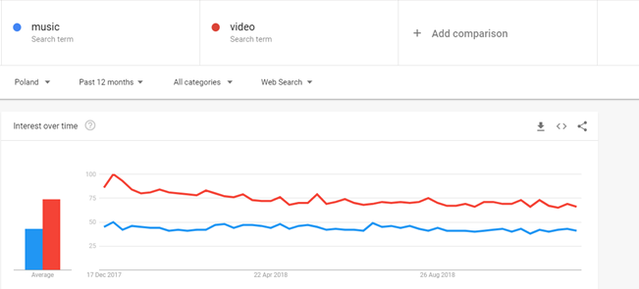
Source: own work
In addition to the above-mentioned free tools, it is possible to conduct media monitoring based on the services of professional companies involved in this industry. Such activities involve additional costs; however, compared to free tools, they offer much more comprehensive solutions including coverage of press, radio, television and the Internet, as well as professional analysis of the monitored material in terms of, among others, the frequency of publication, the tone of individual materials or the proportion between each of the information channels.

Exercise
Use the Google Trends tool. Try out the various options offered by the tool and compare two selected phrases to determine:
- what interest there was for them in terms of time (which phrase prevails in selected periods),
- what interest there was for them in particular regions of the country.
Create an alert in the Google Alerts tool for a selected phrase.
After monitoring the media, we can assess the impact of our media relations. We will find out, among others:
- How many publications have appeared - a huge number of publications is a reason to be happy and even to boast in social media ("Look! The media is writing about us!"). However, if there are not many (or a complete lack), then it is necessary to analyse the reasons or try to call an editorial office in order to convince a journalist to take an interest in the information (how to do this is described under the bullet points).
- Who published the information - we will find out which media we can reliably count on, and which we should work on more to establish stronger relations resulting in publications in the future.
- In what form the information has been published - unlike many small portals that are happy to copy content into their own pages, larger editorial offices rarely publish news in the form they receive. For them it is rather the foundation on which they base their own text. That is why it is worth making sure that everything is fine, and if necessary (for example, the wrong date of an artistic event being given) intervening.
Calling an editorial office is an opportunity to interest a journalist in a subject that could get bogged down in dozens of other e-mails that poured into the editorial mailbox on this and every other day. An editor's work is very intense, everything happens at speed, so to avoid annoying our interlocutor, we should be concise and maximally concrete. It is a good idea to prepare a formula that will help us to present all the most important issues. It may look like this:
"Good morning, my name is XY, yesterday we sent you a press release regarding the concert we are organizing this coming Saturday. I would like to ask for information about whether you managed to get acquainted with our material and if we can count on its publication."
While we are able to cope alone with monitoring internet portals without major problems, it is more difficult with social media. That is why it is worth getting acquainted with the list of the 20 best social media monitoring tools that will effectively solve our problem:
- HubSpot Marketing
- BuzzSumo
- Google Alerts
- Zoho Social
- Qwaya
- Hootsuite
- AdRoll
- SharpSpring
- Sysomos
- Crimson Hexagon
- Meltwater
- Brandwatch
- Synthesio
- Sprout Social
- Cyfe
- AgoraPulse
- Buzzlogix
- Digimind Social
- Madgicz
- CivicFeed
- Crisis management
It may appear that crisis situations cannot concern the area of culture – and that they are rather the domain of large corporations and politicians. Nothing could be further from the truth, even affect a charity organization may be affected by a crisis, if, for example, there is employee abuse in its ranks. That is why in dealing with communication in the field of culture is also worth having a basic concept related to crisis management in the media.
The crisis management model proposed by Mitroff lists five phases:
- Detecting a signal, striving to identify warning signs and taking preventive measures.
- Research and prevention, active searching for and reduction of risk factors.
- Limitation of damage caused by a crisis and actions aimed at limiting its spreading.
- Repairing the effects of the crisis, efforts to restore normal activities.
- Drawing conclusions.
Figure 13. The five phases of crisis management
Source: elaboration based on https://pagecentertraining.psu.edu/public-relations-ethics/ethics-in-crisis-management/lesson-1-prominent-ethical-issues-in-crisis-situations/crisis-and-crisis-management/
We distinguish three stages of a crisis:
- Pre-crisis phase - media monitoring to detect the threat as quickly as possible, taking measures to prepare for dealing with a potential crisis, training employees in crisis communication.
- Crisis phase - collecting information about the crisis and current media reporting on the situation.
- Post-crisis phase - estimating the results of the crisis and the effects of communication.

Figure 14. Phases of a crisis situation

Source: elaboration based on https://pagecentertraining.psu.edu/public-relations-ethics/ethics-in-crisis-management/lesson-1-prominent-ethical-issues-in-crisis-situations/crisis-communication/
This means that most of the time our activities take place during the pre-crisis phase. This time of peace, however, does not allow for complete inaction and satisfaction. We should be vigilant and monitor the possibility of potential problems appearing all of the time. This is also a time when we should prepare a plan of action that we will implement when the need arises.
"An important element is the development of procedures for informing specific target groups, for example employees, as well as the principles of information flow between particular groups in the surroundings and units involved in solving a crisis. The system of relations with the media is also important, and it requires not only the specification of tasks and responsibilities, but also methods of monitoring them. Thus, an early warning system is created on the basis of identifying the symptoms of potential crises".
However, it is not possible to reduce crisis communication to previously determined procedures. They are important, but besides them, one should show communicativeness, speed of reaction and flexibility - each image crisis is different and constitutes an extremely dynamic situation. Therefore, one should remember and avoid the basic errors that are often made during crisis communication - they are described in Figure 15.

Figure 15. Basic errors in crisis communication:

Source: own work
Every person who wants to exist in a wide public space should care about good relations with the media. This applies not only to politicians, but it is also important for the creators of culture, because for them it will be an opportunity to promote their work free of charge.
To create the basis for good relations with the media, it should be remembered that they must be bilateral. Therefore, we should respect the work and time of journalists - not sending them unnecessary and ill-prepared materials, we should try to deliver them at the right time and appreciate the editors who inform the public about our initiatives.
We need to analyse and evaluate the effectiveness of our media relations activities. Media monitoring will be the best way to do this. It will allow us to see where, how much and whether our materials are published at all, and this will be the basis for further analysis and the development of suggestions for future activities.
A crisis will be a particular test for the relations we create with journalists. This is a moment when we will have to demonstrate considerable communication skills, but also count on the media's objectivity. If the editorial staff has a positive relationship with us, they will certainly allow us to provide explanations. Otherwise, they may look for our mistakes and over-emphasize our transgressions. For this reason, our relations with journalists should be at least neutral - remember that media are not our enemy and we should cooperate with them, especially in the face of an image crisis.
In fact, good relations with the media will be a benefit for both sides - for us, because we will have the opportunity to reach a wide audience; for journalists, because they will receive a reliable source of information and access to valuable content. For that to be the case, however, it is necessary to apply the principles presented in these training materials in a long-term and consistent manner, because they will allow us to create satisfying relations with the media.
- Bibliography
- 20 Best Social Media Monitoring Tools of 2018, https://financesonline.com/top-20-social-media-monitoring-tools,
- 500 Writers & Editors Reveal What They Look for in a Pitch, http://www.mediarelationsblog.com/500-writers-editors-reveal-pitch,
- About F.A.M., http://foodasartisticmedium.altervista.org/about-f-a-m/,
- Adam Łaszyn, Media and you, 2015,
- Apple iOS 11 Launch Event in 7 minutes, https://www.youtube.com/watch?v=i5ACY3OiDQ4,
- Crisis Communication, https://pagecentertraining.psu.edu/public-relations-ethics/ethics-in-crisis-management/lesson-1-prominent-ethical-issues-in-crisis-situations/crisis-communication/,
- Dariusz Tworzydło, Public relations practically, 2017,
- Here’s Why Nobody Reads Your Content, https://dejanseo.com.au/web-content/,
- Ivan Walsh, How to Write ‘Scannable’ Web Content, https://www.klariti.com/technical-writing/2017/03/17/write-to-be-scanned-users-dont-read-web-content/,
- Jeremy Horwitz, 10 key things you missed at Apple’s September 2018 Gather Round event, https://venturebeat.com/2018/09/13/10-key-things-you-missed-at-apples-september-2018-gather-round-event/,
- Łukasz Woźniak, Media relations. 10 commandments and more …, https://marketerplus.pl/teksty/artykuly/media-relations-10-przykazan-wiecej,
- Maja Wojciechowska, Media relations as a form of library marketing communication, in: Toruń Bibliological Studies, 2009, nr 2 (3),
- Matt Phillpott, How to write a blog post? The inverted pyramid approach, https://bloggingforhistorians.wordpress.com/2013/08/07/how-to-write-a-blog-post-the-inverted-triangle-approach/,
- Naman Sehgal, Eye Tracking and The Best UX Practices in The Mobile World, https://medium.com/nyc-design/eye-tracking-and-the-best-ux-practices-in-the-mobile-world-a101f67f20dd,
- FROM INFORMATION TO STRATEGY, http://www.proto.pl/porady-praktyczne/amet-augue-lobortis-vulpes,
- The inverted pyramid, https://www.slideshare.net/mindsupporterscom/odwrcona-piramida-70097847,
- Piotr Kowalczyk, How people read content online (infographic), http://passwordincorrect.com/how-people-read-content-online-infographic/,
- UMW Report, August 2017,
- UMW Report, January 2017,
- Sharon Hurley Hall, What is a Heat Map, How to Create One, Examples and Case Studies, https://www.crazyegg.com/blog/understanding-using-heatmaps-studies/,
- vanalika, What You Should Expect About Apple March Event, http://www.itcertswin.com/what-you-should-expect-about-apple-march-event.html.

Sharon Hurley Hall, What is a Heat Map, How to Create One, Examples and Case Studies, https://www.crazyegg.com/blog/understanding-using-heatmaps-studies/, on 15.12.2018
Naman Sehgal, Eye Tracking and The Best UX Practices in The Mobile World, https://medium.com/nyc-design/eye-tracking-and-the-best-ux-practices-in-the-mobile-world-a101f67f20dd, on 15.12.2018
Here’s Why Nobody Reads Your Content, https://dejanseo.com.au/web-content/, on 15.12.2018
UMW Report, January 2017, p. 11.
Odwrócona piramida, https://www.slideshare.net/mindsupporterscom/odwrcona-piramida-70097847, on 16.12.2018
About F.A.M., http://foodasartisticmedium.altervista.org/about-f-a-m/, on 16.12.2018
FROM INFORMATION TO STRATEGY, http://www.proto.pl/porady-praktyczne/amet-augue-lobortis-vulpes, on 16.12.2018
Łukasz Woźniak, Media relations. 10 commandments and more …, https://marketerplus.pl/teksty/artykuly/media-relations-10-przykazan-wiecej/, on 16.12.2018
Dariusz Tworzydło, Public relations practically, 2017, s. 224.
Adam Łaszyn, Media and you, 2015, s. 218.
Jeremy Horwitz, 10 key things you missed at Apple’s September 2018 Gather Round event, https://venturebeat.com/2018/09/13/10-key-things-you-missed-at-apples-september-2018-gather-round-event/, on 16.12.2018
Apple iOS 11 Launch Event in 7 minutes, https://www.youtube.com/watch?v=i5ACY3OiDQ4, on 16.12.2018
vanalika, What You Should Expect About Apple March Event, http://www.itcertswin.com/what-you-should-expect-about-apple-march-event.html, on 16.12.2018 r.
Łukasz Woźniak, Media relations. 10 commandments and more …, https://marketerplus.pl/teksty/artykuly/media-relations-10-przykazan-wiecej/, on 16.12.2018
500 Writers & Editors Reveal What They Look for in a Pitch, http://www.mediarelationsblog.com/500-writers-editors-reveal-pitch/, on 16.12.2018
Łukasz Woźniak, Media relations. 10 commandments and more …, https://marketerplus.pl/teksty/artykuly/media-relations-10-przykazan-wiecej/, on 16.12.2018
UMW Report, August 2017, p 10-11.
20 Best Social Media Monitoring Tools of 2018, https://financesonline.com/top-20-social-media-monitoring-tools/, on 16.12.2018
Crisis Communication, https://pagecentertraining.psu.edu/public-relations-ethics/ethics-in-crisis-management/lesson-1-prominent-ethical-issues-in-crisis-situations/crisis-communication/, on 16.12.2018
Crisis Communication, https://pagecentertraining.psu.edu/public-relations-ethics/ethics-in-crisis-management/lesson-1-prominent-ethical-issues-in-crisis-situations/crisis-communication/, on 16.12.2018
Dariusz Tworzydło, Public relations practically, 2017, s. 176.

